

YEAR 11 ATAR HUMAN BIOLOGY

Task 5:
Circulatory and Respiratory Test

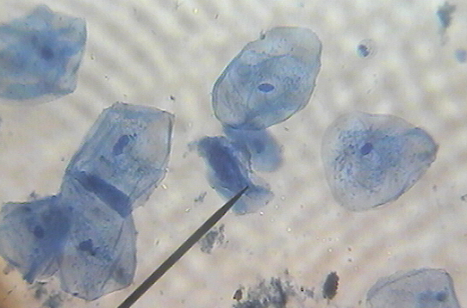

-DO NOT MARK THIS BOOKLET-

Multiple Choice: 15 marks
Short Answer: 60 marks
TOTAL 75 MARKS

Section A: Multiple Choice (15 Marks)
Answer all questions by placing and X through the most correct answer on the multiple choice answer sheet.

- The basic structural units of life are:

  - tissue
  - organs
  - systems
  - cells

- The mitochondria:

  - Give rise to the endoplasmic reticulum
  - Are usually double-layered organisms with finger like extensions
  - Are centre of RNA synthesis
  - Are centres of cellular respiration.

- Mammalian sperm cells expend a large amount of energy in moving through the female reproductive tract.

On the basis of this information you would predict that these cells would contain a large number of:

  - vacuoles
  - mitochondria
  - ribosomes
  - chloroplasts

- The organelles of the cell are concerned in essential processes, one of which is the synthesis of protein. This particular organelle is the:

  - ribosome
  - golgi body
  - nucleolus
  - endoplasmic reticulum

- All cells obtain energy for their general metabolic activity by the oxidation of glucose. This basic process is known as cellular

  - reproduction
  - respiration
  - photosynthesis
  - metabolism

- Active transport occurs when the substances move across membranes:

  - From lower to higher concentration
  - From higher to lower concentrations
  - By osmosis
  - By simple diffusion

The next three questions refer to the following diagram

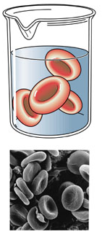
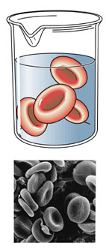
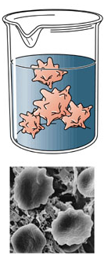
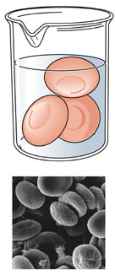
D: Normal blood plasma
A: 0.9% Saline
B: 2% Saline
C: 0% Saline

- Some Red Blood cells were placed in three different saline solutions of 0.9%, 2%, 0%. A forth beaker shows cell in the body’s normal plasma. Which of the above solutions can be said to have the same saline concentration as blood plasma?

- 0.9%
- 2%
- 0%
- More information is required

- The cells in beaker C have swelled and the solution is said to be hypotonic. The cells in beaker C have swelled because:

- The ion content inside the beaker is higher than the ionic content of the blood cells.
- Water has moved into the blood cells due to a lower water concentration inside the cells
- Water has moved out of the cell and into the surrounding beaker
- Salt ions have moved into the cell due to a low concentration of salt ions in the beaker

9. The cells in beaker D: Normal Plasma are the

- Experimental group
- Control Group
- Independent variable
- Dependent variable

The generalised equation for respiration is:

Glucose + Oxygen → Carbon dioxide + Water + Energy.

10. Energy for the cell’s use is released in the form of

- Heat
- ADP
- ATP
- DNA

11. If the nucleus was removed from a cell which of the following would occur?

- nothing
- the cell would die
- reproduction could not occur but all else would remain normal
- cell respiration would not take place

12. On a light microscope the objective lens

- changes the amount of light entering the microscope
- moves the stage up and down
- magnifies an image by 4x, 10x or 40x
- holds the slide in place

13. A student viewed a prepared slide of connective tissue using 10x ocular and 40x objective lenses. What was the total magnification?

- 40x
- 50x
- 140x
- 400x

14. The student saw this image of loose connective tissue. The lines running through the tissue are
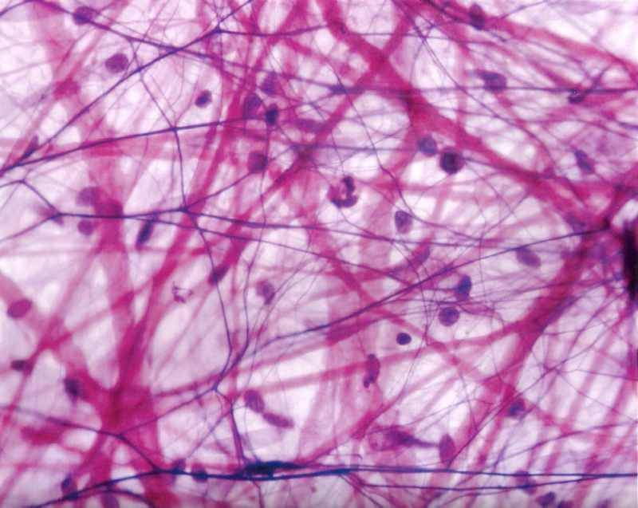

- collagen and elastin fibres
- cell membranes
- axons
- cilia

15. Bone is which type of tissue?

- Epithelial
- Connective
- Muscular
- Nervous

END OF MULTIPLE CHOICE
YEAR 11 ATAR HUMAN BIOLOGY

Test 1:
Cellular Processes

SCORES:
MC: /15

SA: /60

TOTAL: /75

_______ %

NAME:_____________________________

TEACHER:__________________________

DATE:______________________________

Section A: Multiple choice (15 Marks)
Answer all questions by circling the most correct answer on the multiple choice answer sheet.

1. a b c d 11. a b c d
2. a b c d 12. a b c d
3. a b c d 13. a b c d
4. a b c d 14. a b c d
5. a b c d 15. a b c d
6. a b c d
7. a b c d
8. a b c d
9. a b c d
10. a b c d
PART B: Short Answer Section (60 marks)

Question 1 [8 marks]

A group of researchers wished to compare the ability of two different treatments for relieving tension headache pain. They set up the following test procedure that ran over a six month period.

They selected 57 volunteers and divided the volunteers into three groups

Group A 15 persons received treatment A - a commonly used tablet

Group B 22 persons received treatment B - a medical ointment applied to the temples of the volunteers

Group C 20 Persons received treatment C – an inactive mint extract applied to the temples of the volunteers

The volunteers were given the alternative treatments to use each time they suffered a headache. At fixed times after the start of the treatment each volunteer recorded the severity of the headache using the following scale:

0 = no headache 1-2 = mild headache 3-4 = moderate headache 5 = severe headache

The results for each group were averaged and tabulated below:

 | Severity of Headache (Average)
Minutes after treatment | GROUP A | GROUP B | GROUP C
0 | 3.7 | 4.0 | 3.6
5 | 3.8 | 3.4 | 3.7
)10 | 3.6 | 3.2 | 3.8
20 | 3.2 | 2.8 | 3.4
45 | 2.5 | 2.3 | 3.0
120 | 2.1 | 1.8 | 2.6

a) Graph the data in the space provided (5 marks)

b) For Group B how long after beginning the treatment did it take for the headache to be reduced to a rating of 2? (1 mark)

c) In this experiment what was the dependent variable? (1 mark)

d) Write a conclusion for this experiment (1 mark)

Question 2 [6 marks]
A
Refer to following to the diagram
B
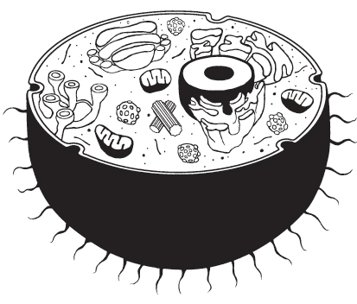
C
F

E

D

a. Name each of the following organelles from the diagram above (3 marks – ½ each)

A: _______________________________
B: _______________________________
C: _______________________________
D: _______________________________
E: _______________________________
F: _______________________________

b. What is the function of the following organelles labelled? (3 marks)

A:__________________________________________________________________________ ___________________________________________________________________________
B: _________________________________________________________________________ ___________________________________________________________________________
C: _________________________________________________________________________ ___________________________________________________________________________

Question 3 [9 marks]
Using the diagrams below, name the type of cell transport associated with each (5 marks)

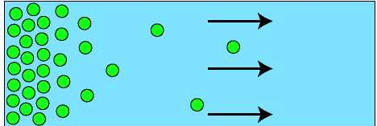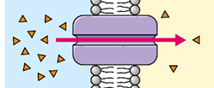

a___________________________ b___________________________
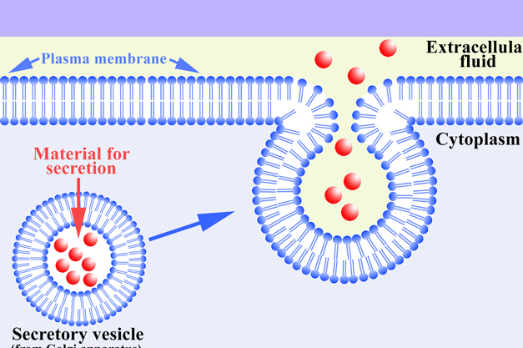

c__________________________

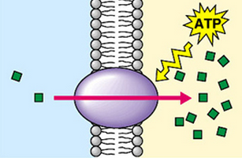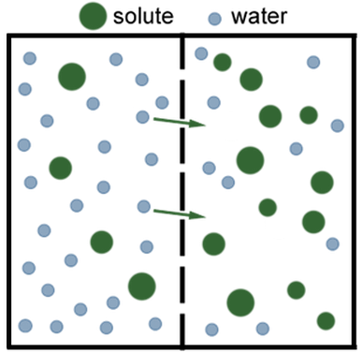

d_____________________________ e____________________________
Question 4
State the letter above (a-e) which corresponds to the situations below (4 marks)
- Carbon Dioxide from the bloodstream entering the lungs ___________________
- The use of energy to move Hydrogen ions into the kidney tubules against the concentration gradient ________________________________
- A large amino acid molecule entering the a cell along the concentration gradient _________________________________
- Water entering the bloodstream ________________________________

Question 6 [4 marks]
The diagram below shows some of the internal structures found in a typical Amoeba:
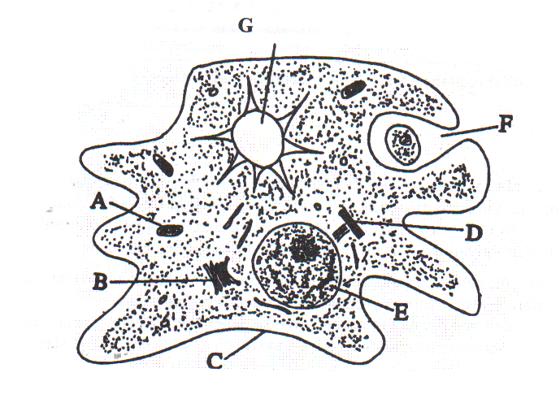

You are observing this cell under the low power of a microscope. The diameter of the field of view is 1.5mm and you estimate that five cells would fit across the field of view.

a) What is the approximate width of an Amoeba cell in µm?
(2)
b) Estimate the diameter of structure E in µm
(2)
Question 7 [7 marks]

a) The human body can be organised structurally from microscopic to large as:

_cells_ → _______________ → ________________ → __________________ (1 mark)

b) Complete this table about muscular tissue (4 marks)

Name | Control | Striated | Found in
Skeletal | Voluntary |  | Biceps brachii
 | Involuntary | Yes | Heart
 | Involuntary | No

c) Name the type of muscle tissue in the following diagrams
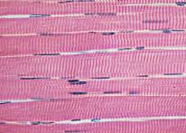
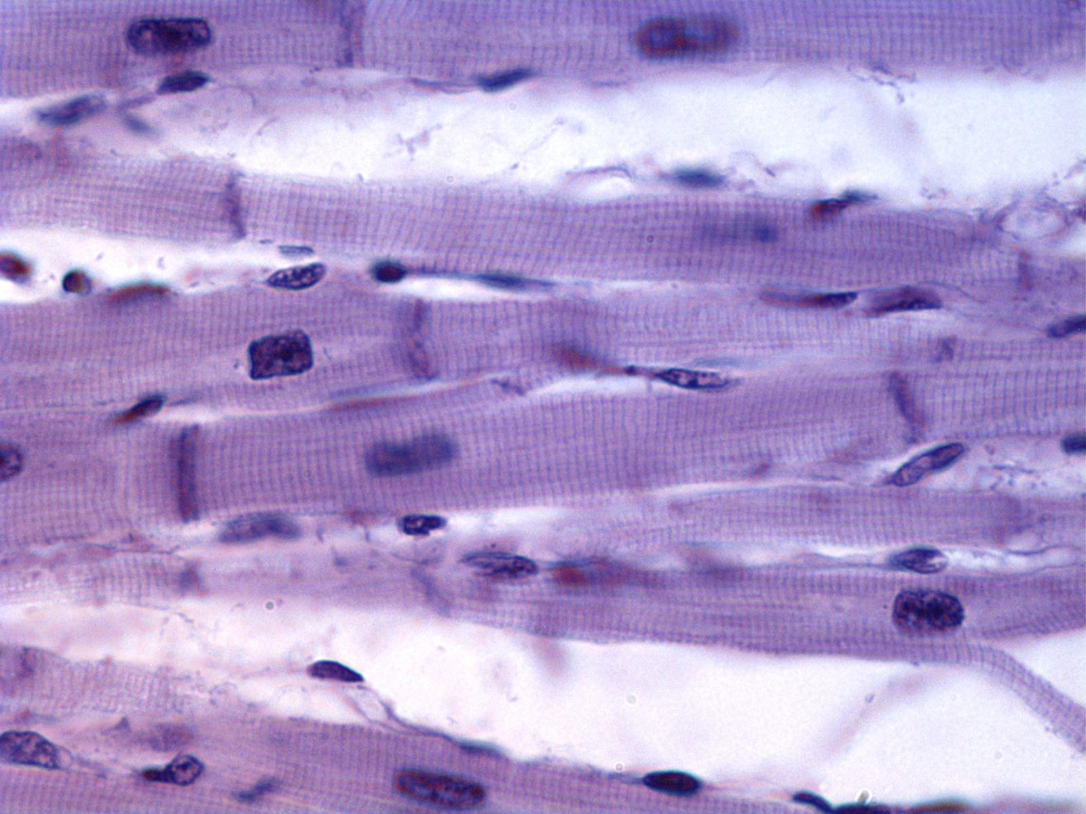

(i) _________________________ (ii) _________________________

(2 marks)

Question 8 [8 marks]

The following diagram shows an enzyme during a reaction
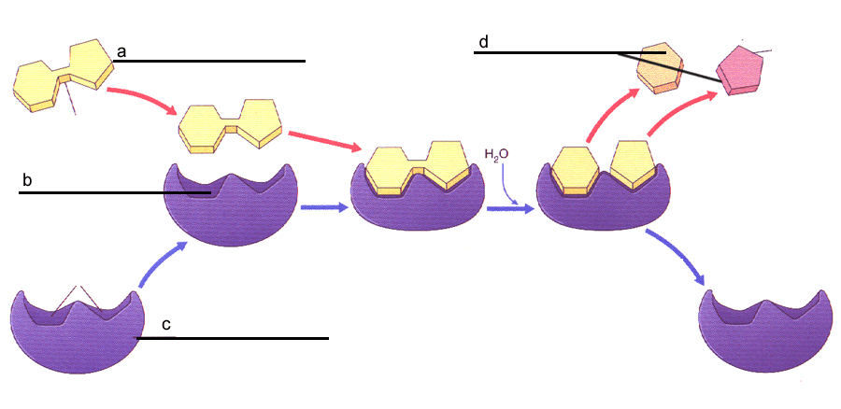

  - Label the components a - d above (2 marks)
  - Enzymes are specific. Explain what is meant by this (2 marks)

  - What type of metabolic reaction is represented in the diagram above (1 mark)

d) High body temperatures experienced during an infection can be dangerous and result in death. Explain why this happens by referring to enzyme activity (3 marks)

Question 9 (13 marks)
Cells use chemical energy.
- Define chemical energy. (1 marks)

- List five cell processes that require energy. (5 marks)

- Cells transfer the energy released from glucose into ATP molecules. Give three reasons why this is necessary.
(3 marks)

- Complete the following table

Characteristics | Aerobic Respiration | Anaerobic Respiration
Where it occurs in a cell?
Reactants
Products
Net ATP gain
(4 marks)

Question 10 (5 marks)
Refer to the following diagram
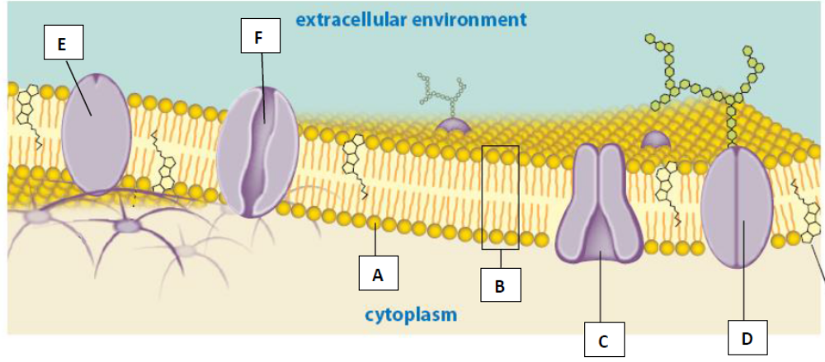
(a) Label the following components of the cell membrane
A ___________________________________________

B ___________________________________________

D ___________________________________________

F ___________________________________________ (2 marks)

(b) Explain how structure C functions to enable substances to cross the cell membrane. Give an example of substance that it transports.

(3 marks)

-END OF PART B-

Sources
Question 1 picture

http://room233.wikispaces.com/Fantastic+Four [Accessed 6/3/2013]

Question 2 picture

http://tonkydesigns.com/blog/wp-content/gallery/2009-random/animal-cell-diagram-wall-sticker-silo2.jpg [Accessed 6/3/2013]

Question 3 pictures

http://1.bp.blogspot.com/-97RXS-DIJ4c/UIpRGL8ZkrI/AAAAAAAAAX0/MRG0Pq0D3D4/s1600/diffusion.jpg [Accessed 6/3/2013]

http://thebasisoflife.wikispaces.com/file/view/c8x16types-transport.jpg/30540339/c8x16types-transport.jpg [Accessed 6/3/2013]

http://bulldogbiology.com/newsite/lib/exe/fetch.php?w=105&h=105&cache=cache&media=images:cell_trans.gif [Accessed 6/3/2013]

http://askabiologist.asu.edu/sites/default/files/resources/activities/body_depot/viral_attack/phagocytosis.gif [Accessed 6/3/2013]

http://www.linkpublishing.com/exocytosis5.jpg [Accessed 6/3/2013]

http://thesproutlingwrites.files.wordpress.com/2012/07/osmosis-diagram.png [Accessed 6/3/2013]

Question 5 pics

http://upload.wikimedia.org/wikipedia/commons/thumb/3/37/Wilson1900Fig2.jpg/350px-Wilson1900Fig2.jpg [Accessed 6/3/2013]

